**BCSE308P COMPUTER NETWORKS**

**ASSIGNMENT**

**NAME: RISHAAN JACOB KURIAKOSE REG. NO.: 21BPS1394**

**CISCO PACKET TRACER NETWORKS**

LAN Network Consisting of Hub and Switch

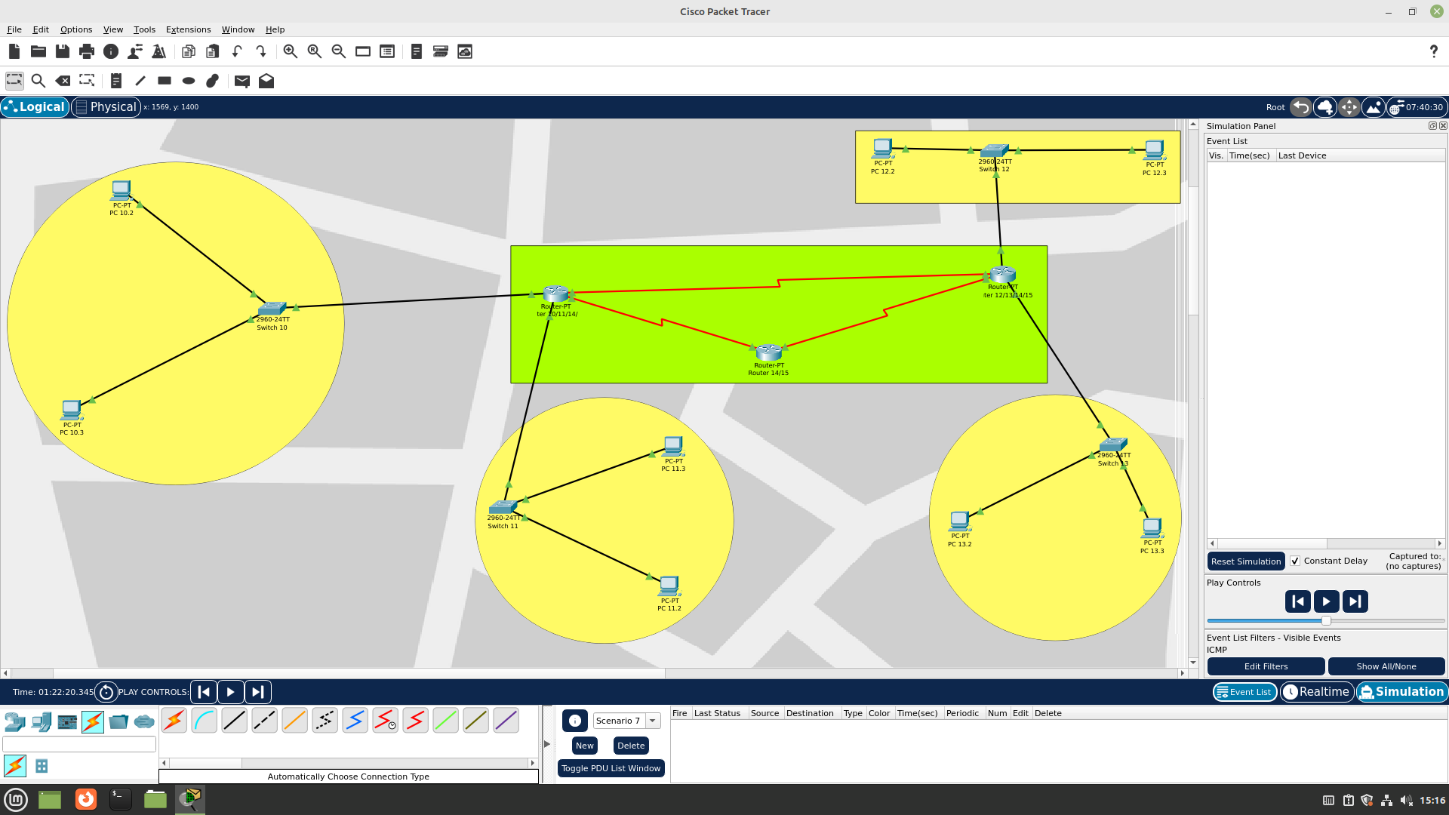

Node 1 IP Configuration

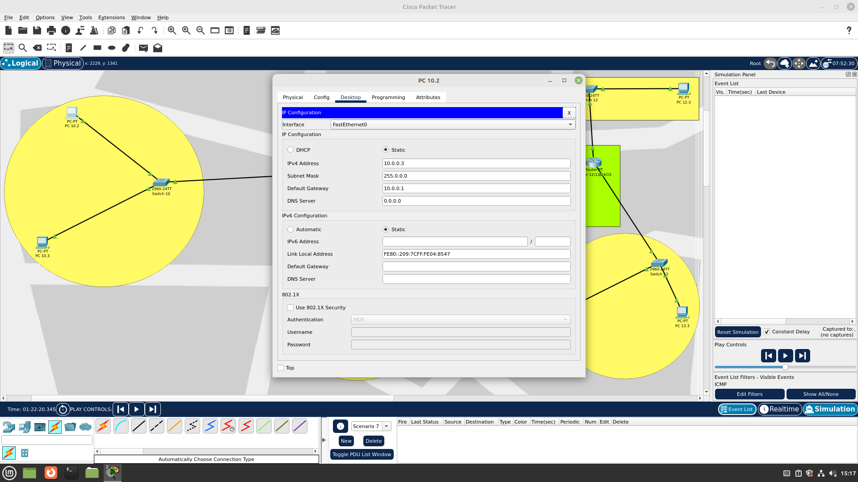

Node 2 IP Configuration

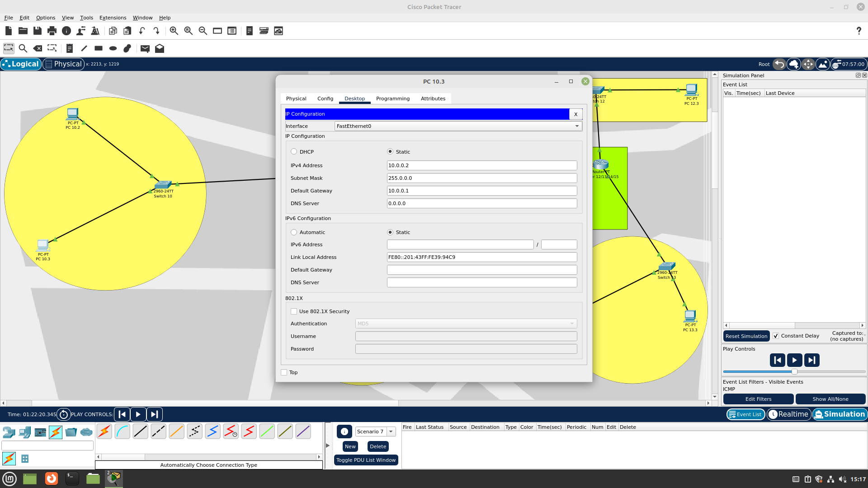

Node 3 IP Configuration

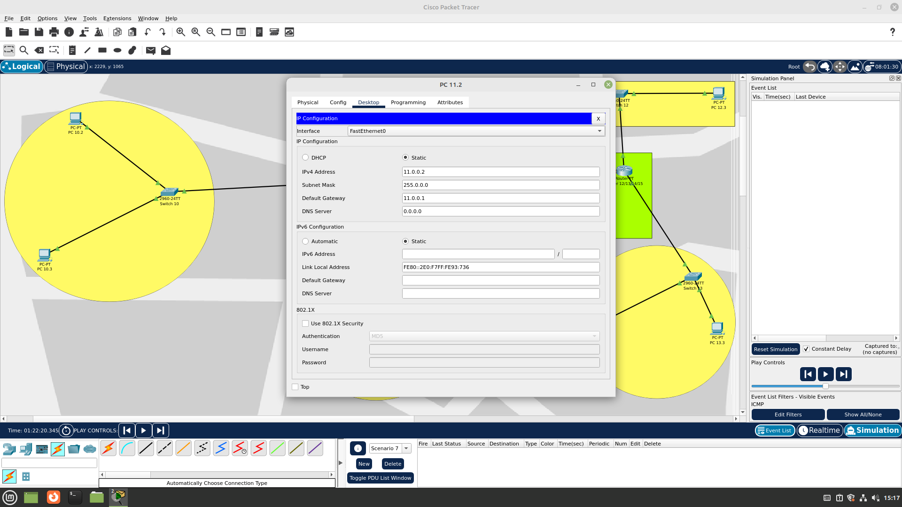

Node 4 IP Configuration

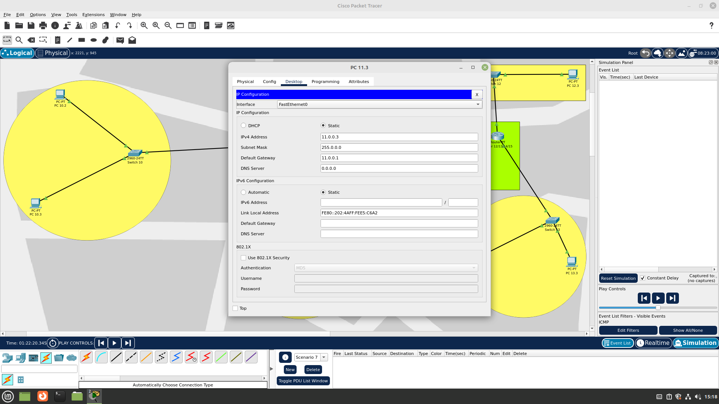

Node 5 IP Configuration

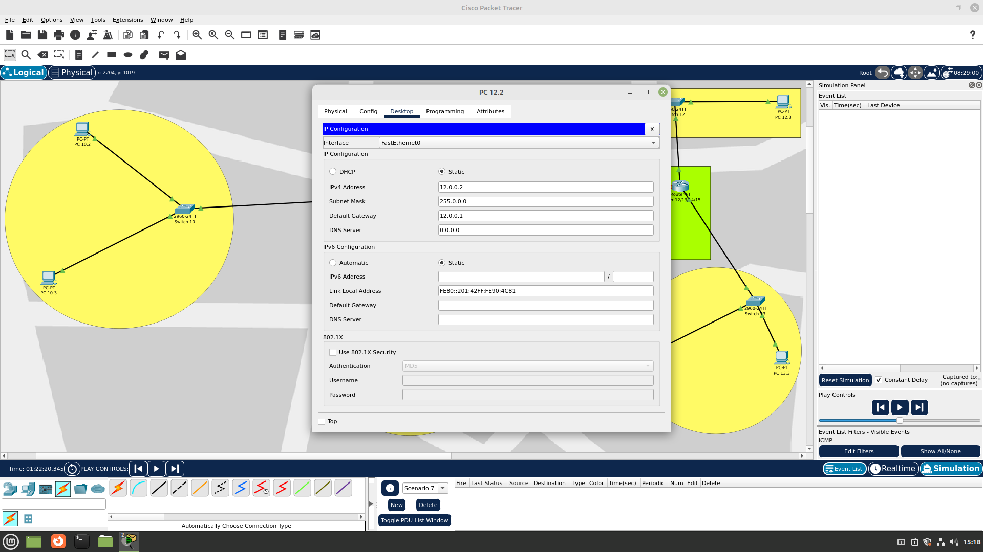

Node 6 IP Configuration

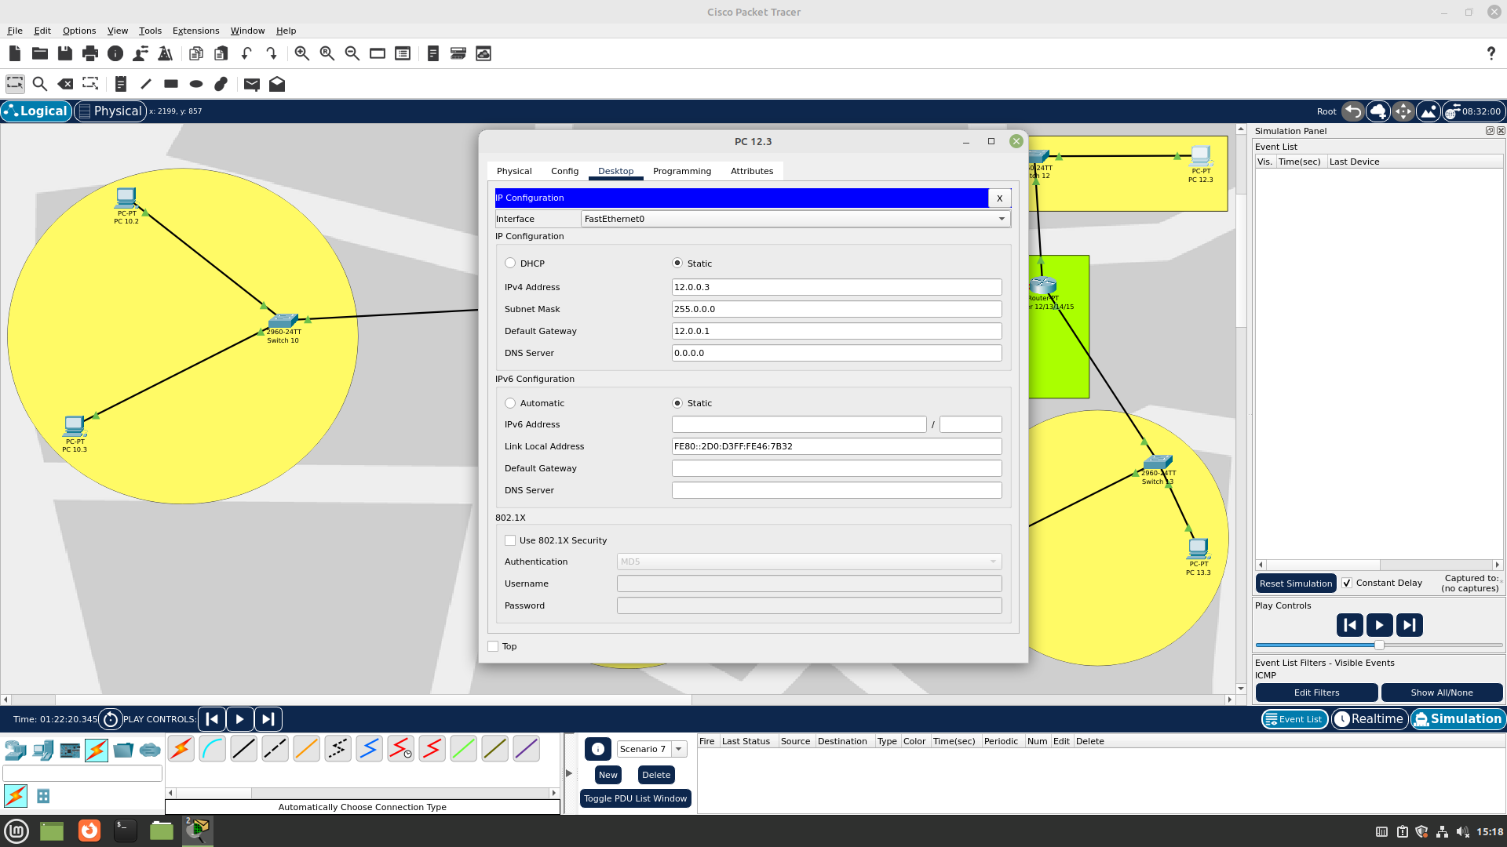

Node 7 IP Configuration

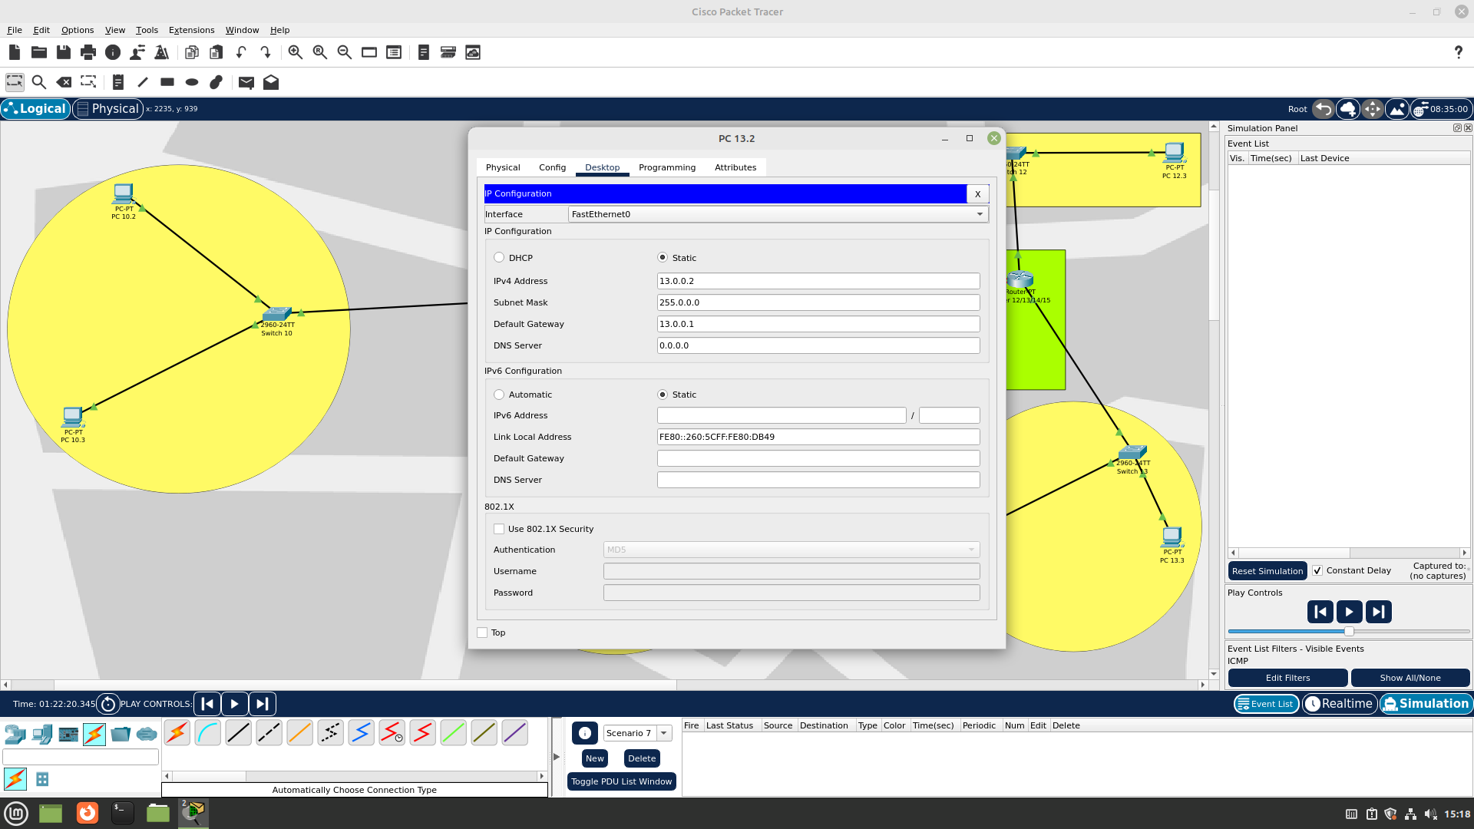

Node 8 IP Configuration

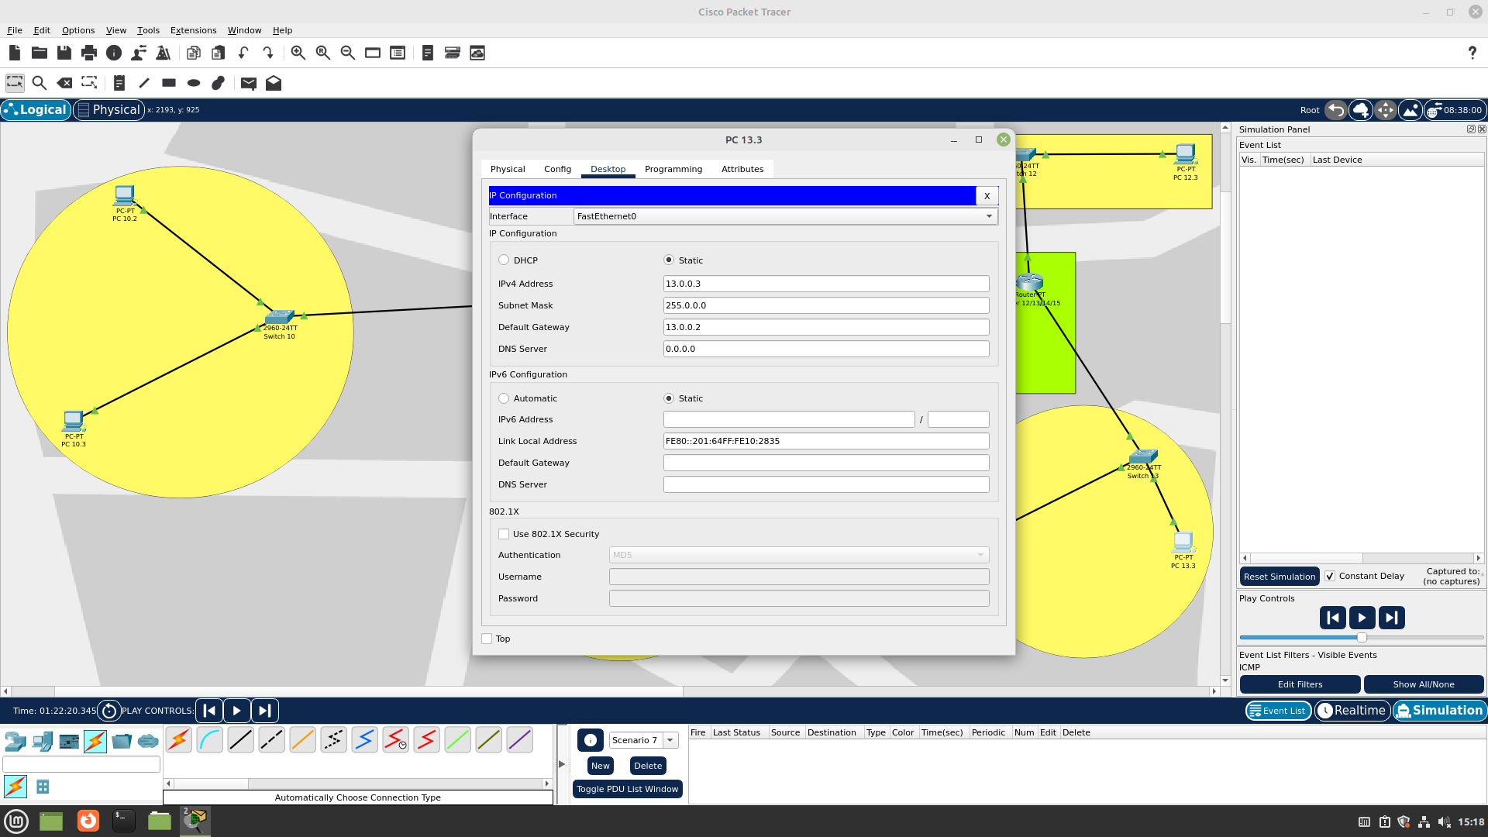

Router 1 Network 10 Configuration

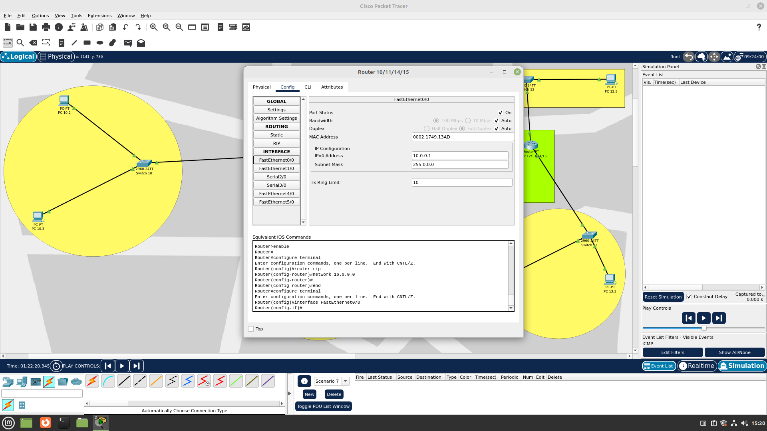

Router 1 Network 11 Configuration

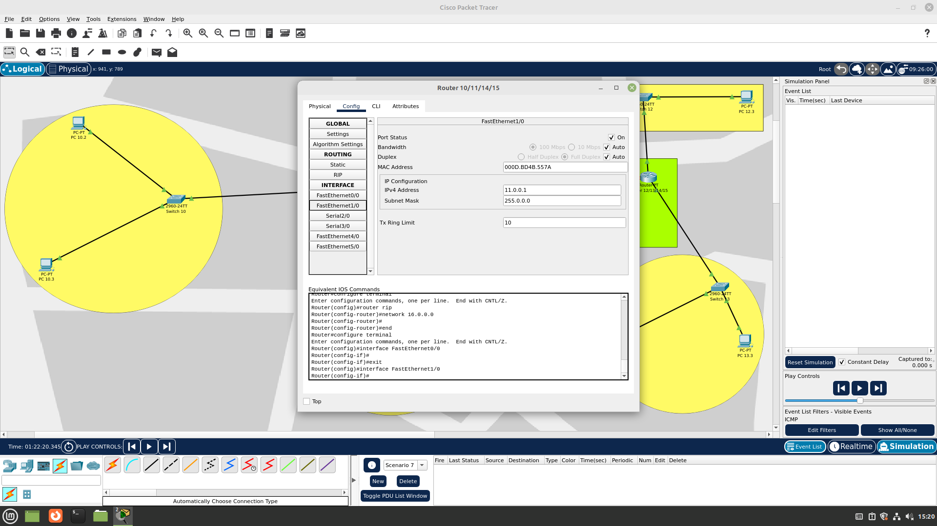

Router 1 Network 14 Configuration

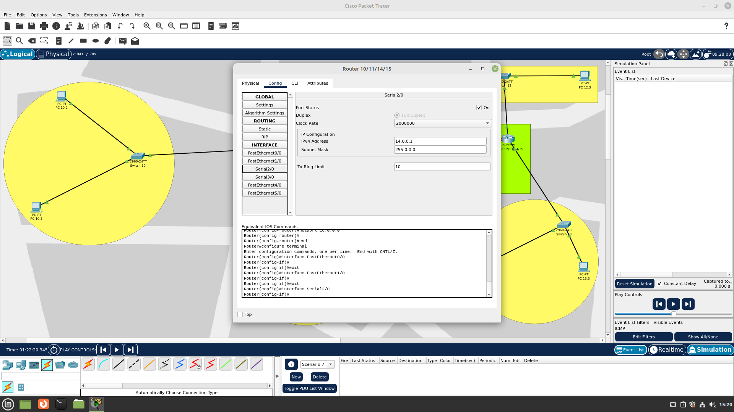

Router 1 Network 15 Configuration

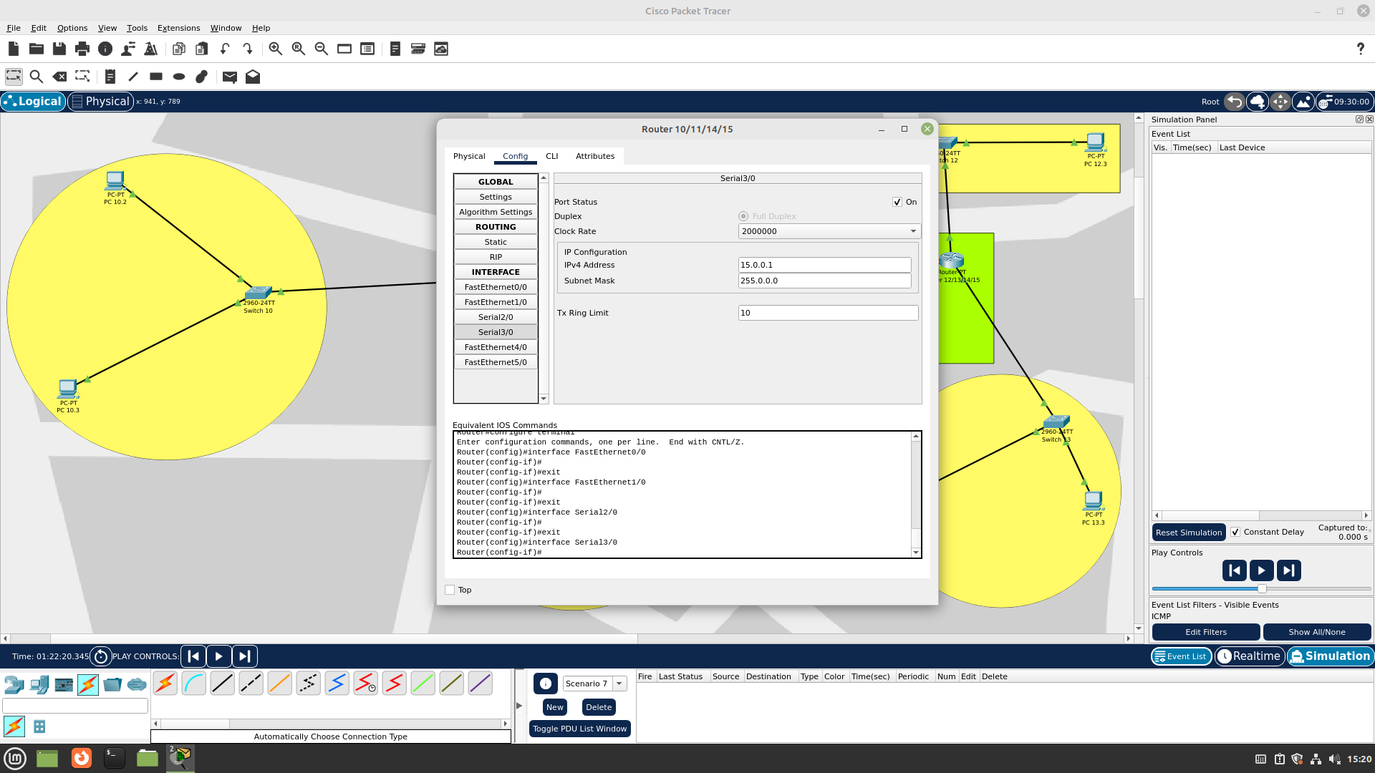

Router 1 RIP Configuration

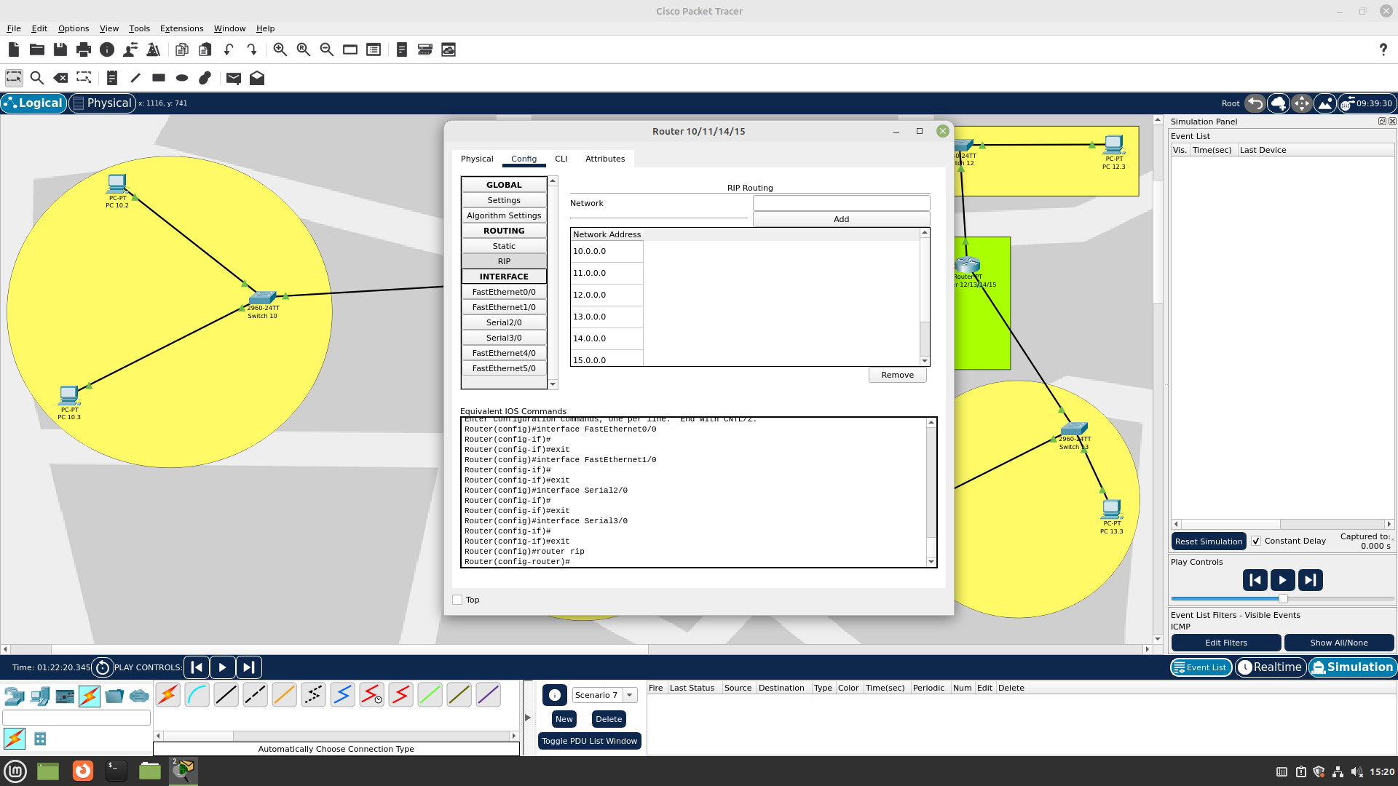

Router 2 Network 12 Configuration

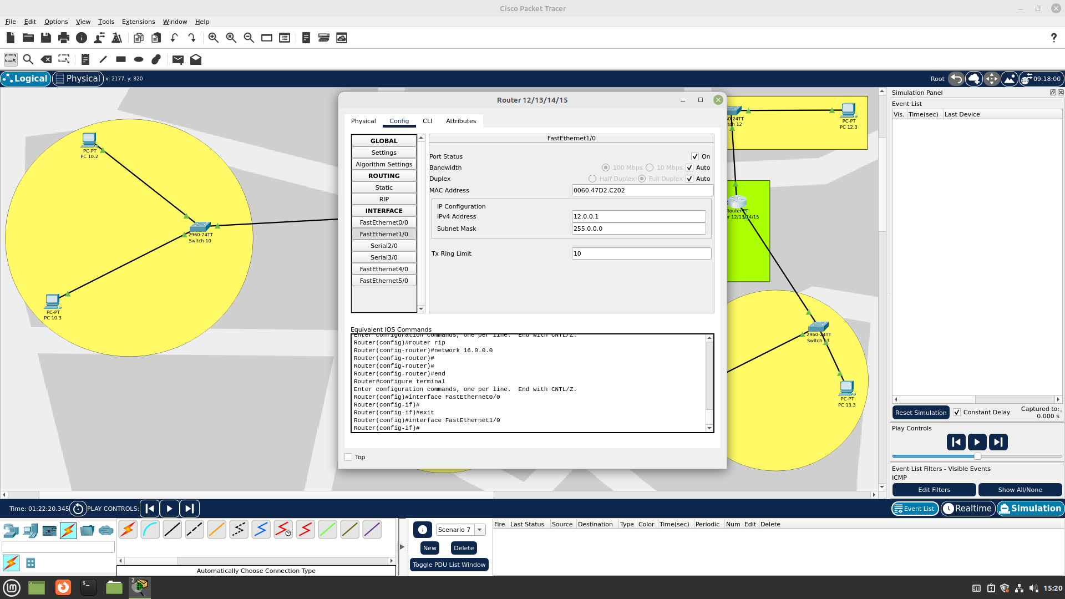

Router 2 Network 13 Configuration

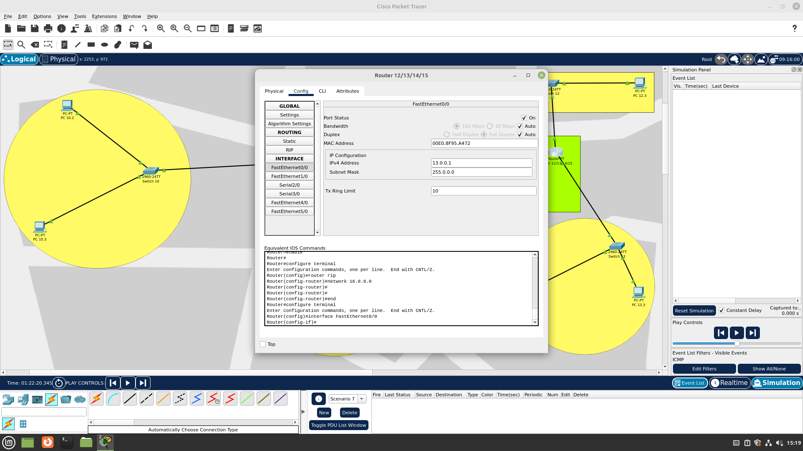

Router 2 Network 14 Configuration

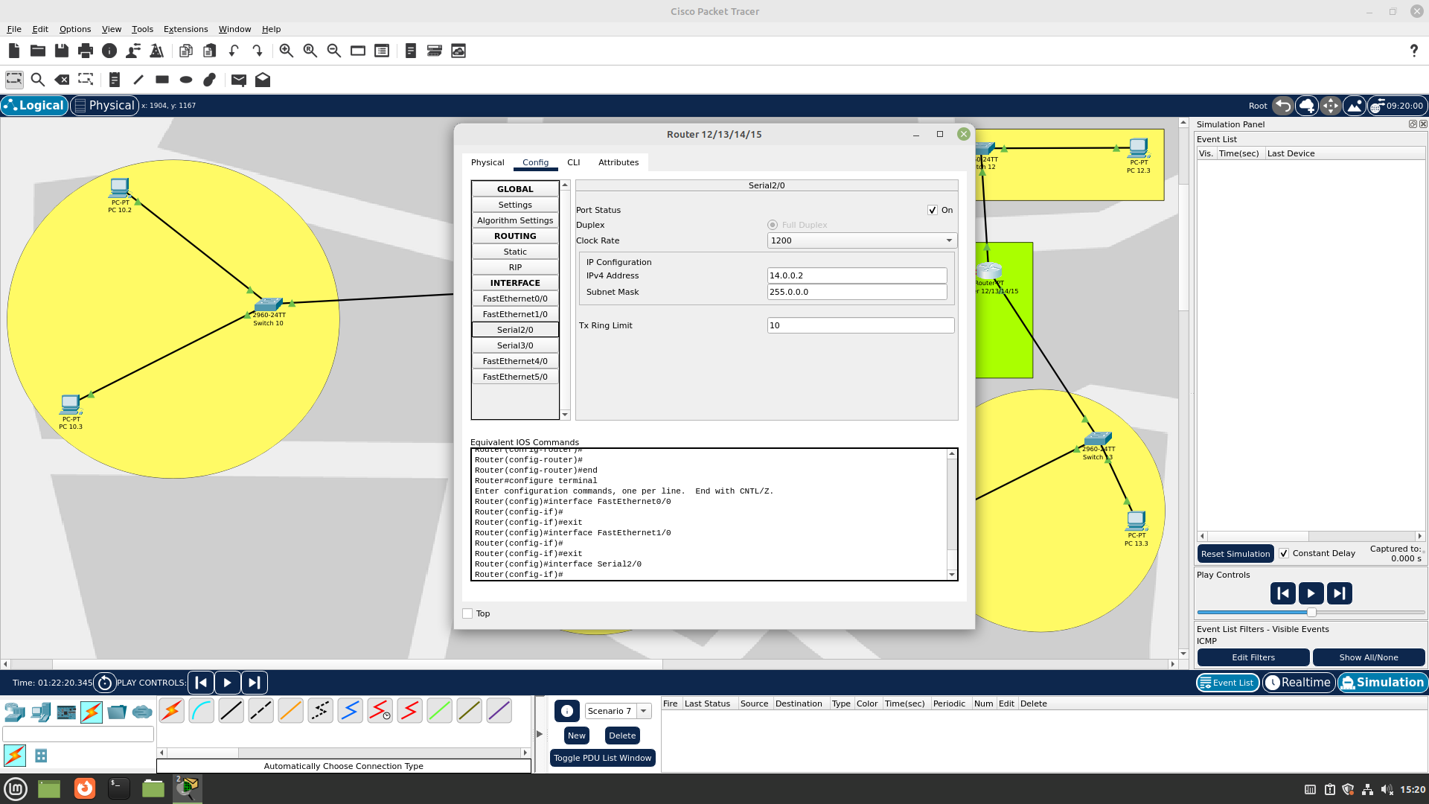

Router 2 Network 16 Configuration

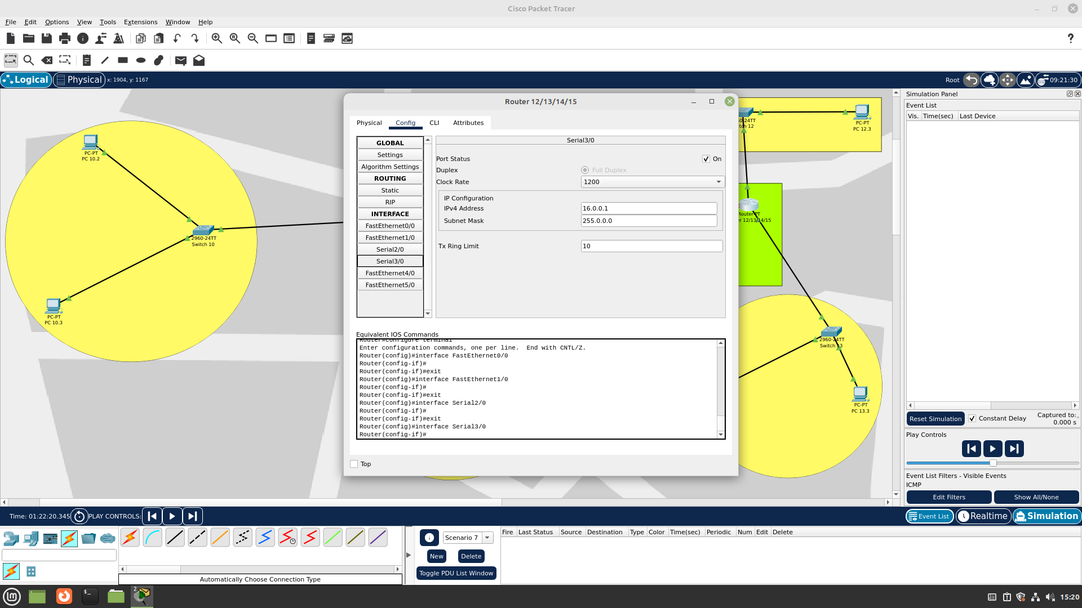

Router 2 RIP Configuration

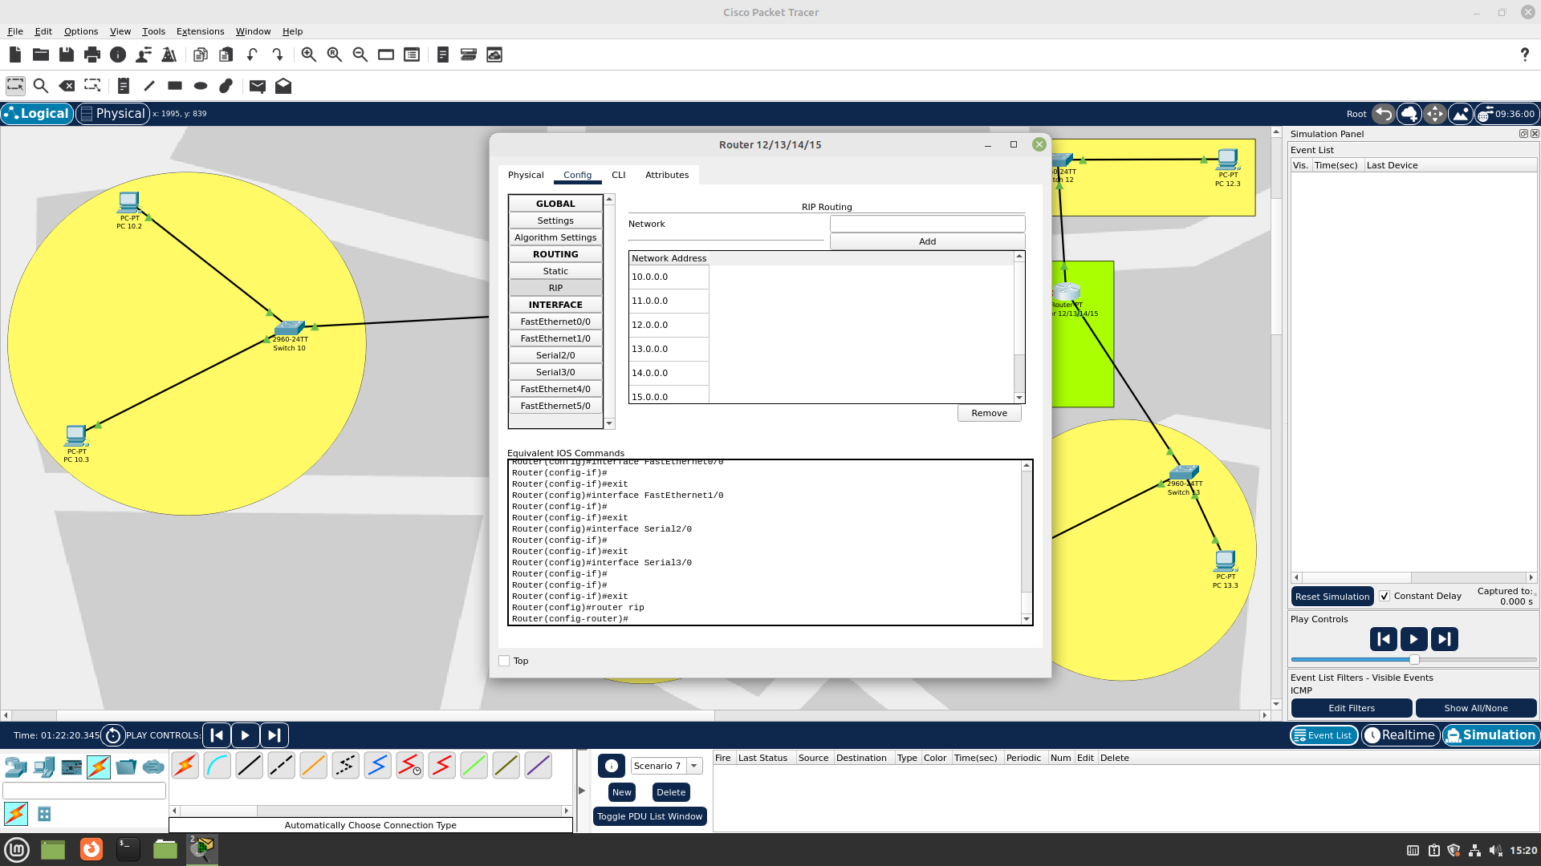

Router 3 Network 14 Configuration

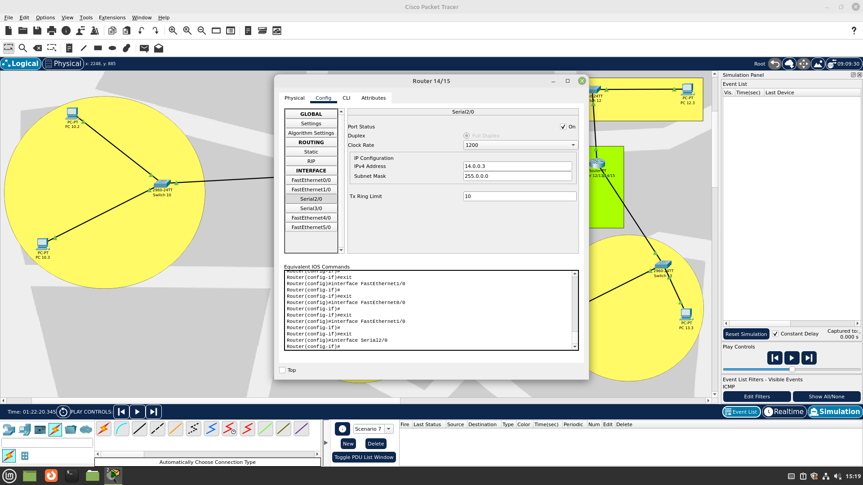

Router 3 Network 15 Configuration

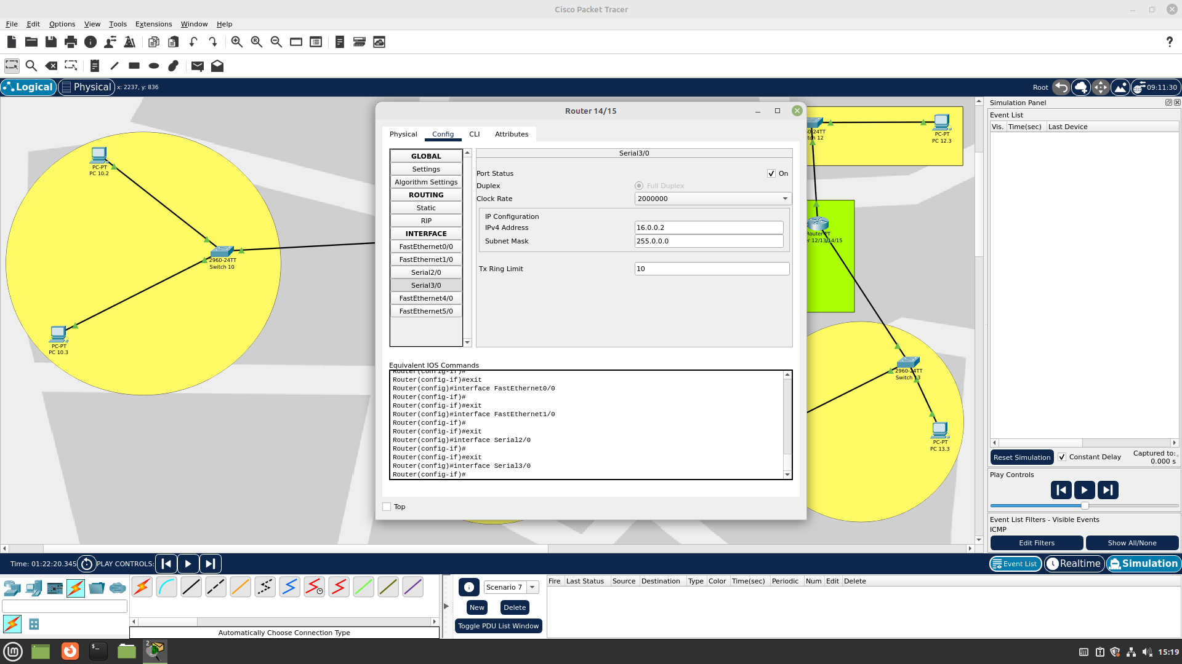

Router 3 RIP Configuration

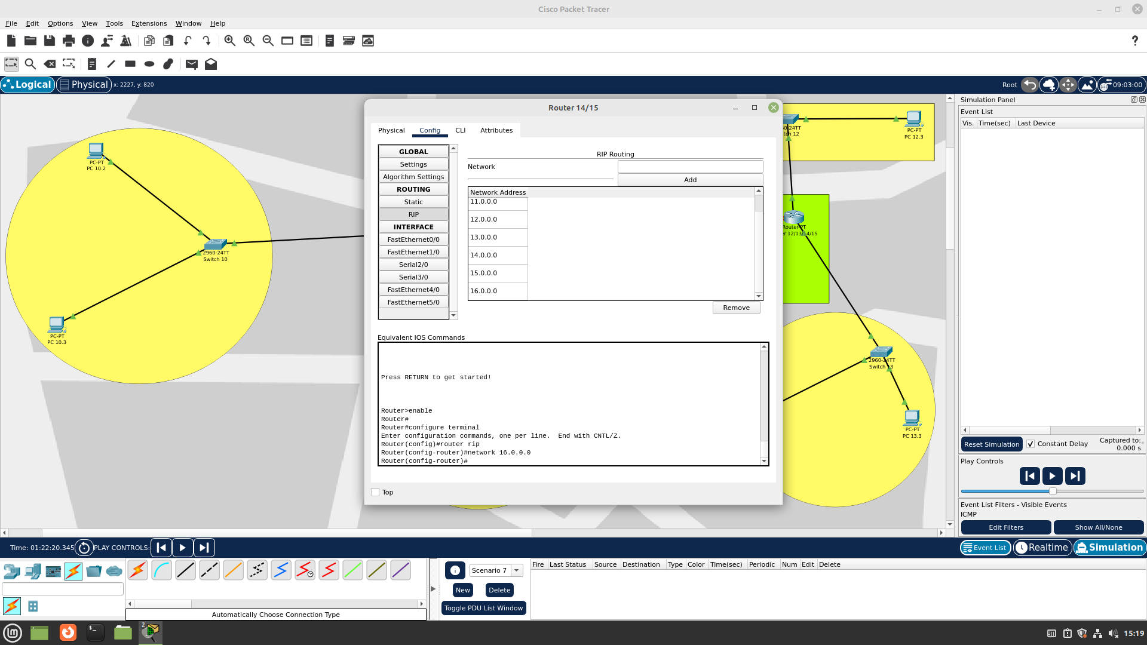

Simple Packet Transfer from Node 1 to Node 5

Step 1

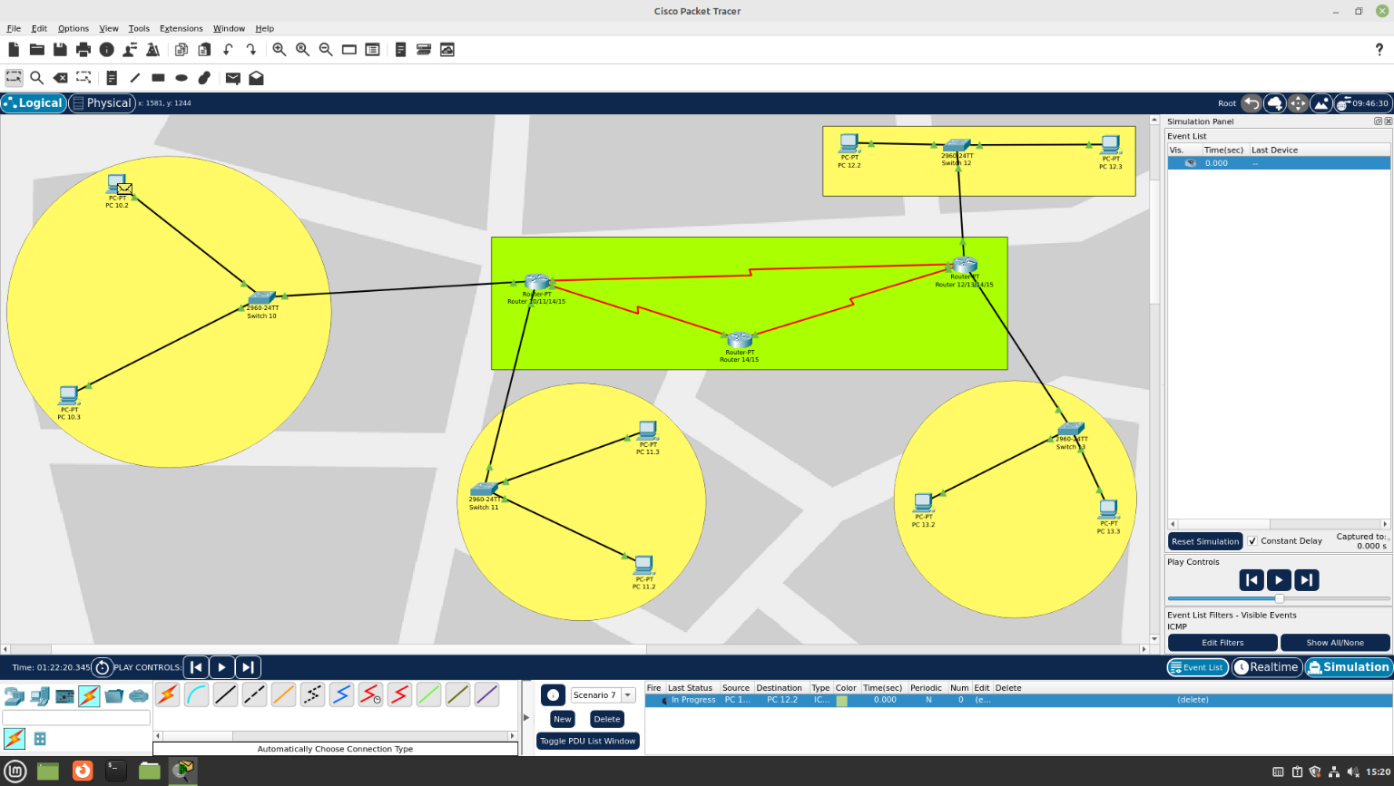

Step 2

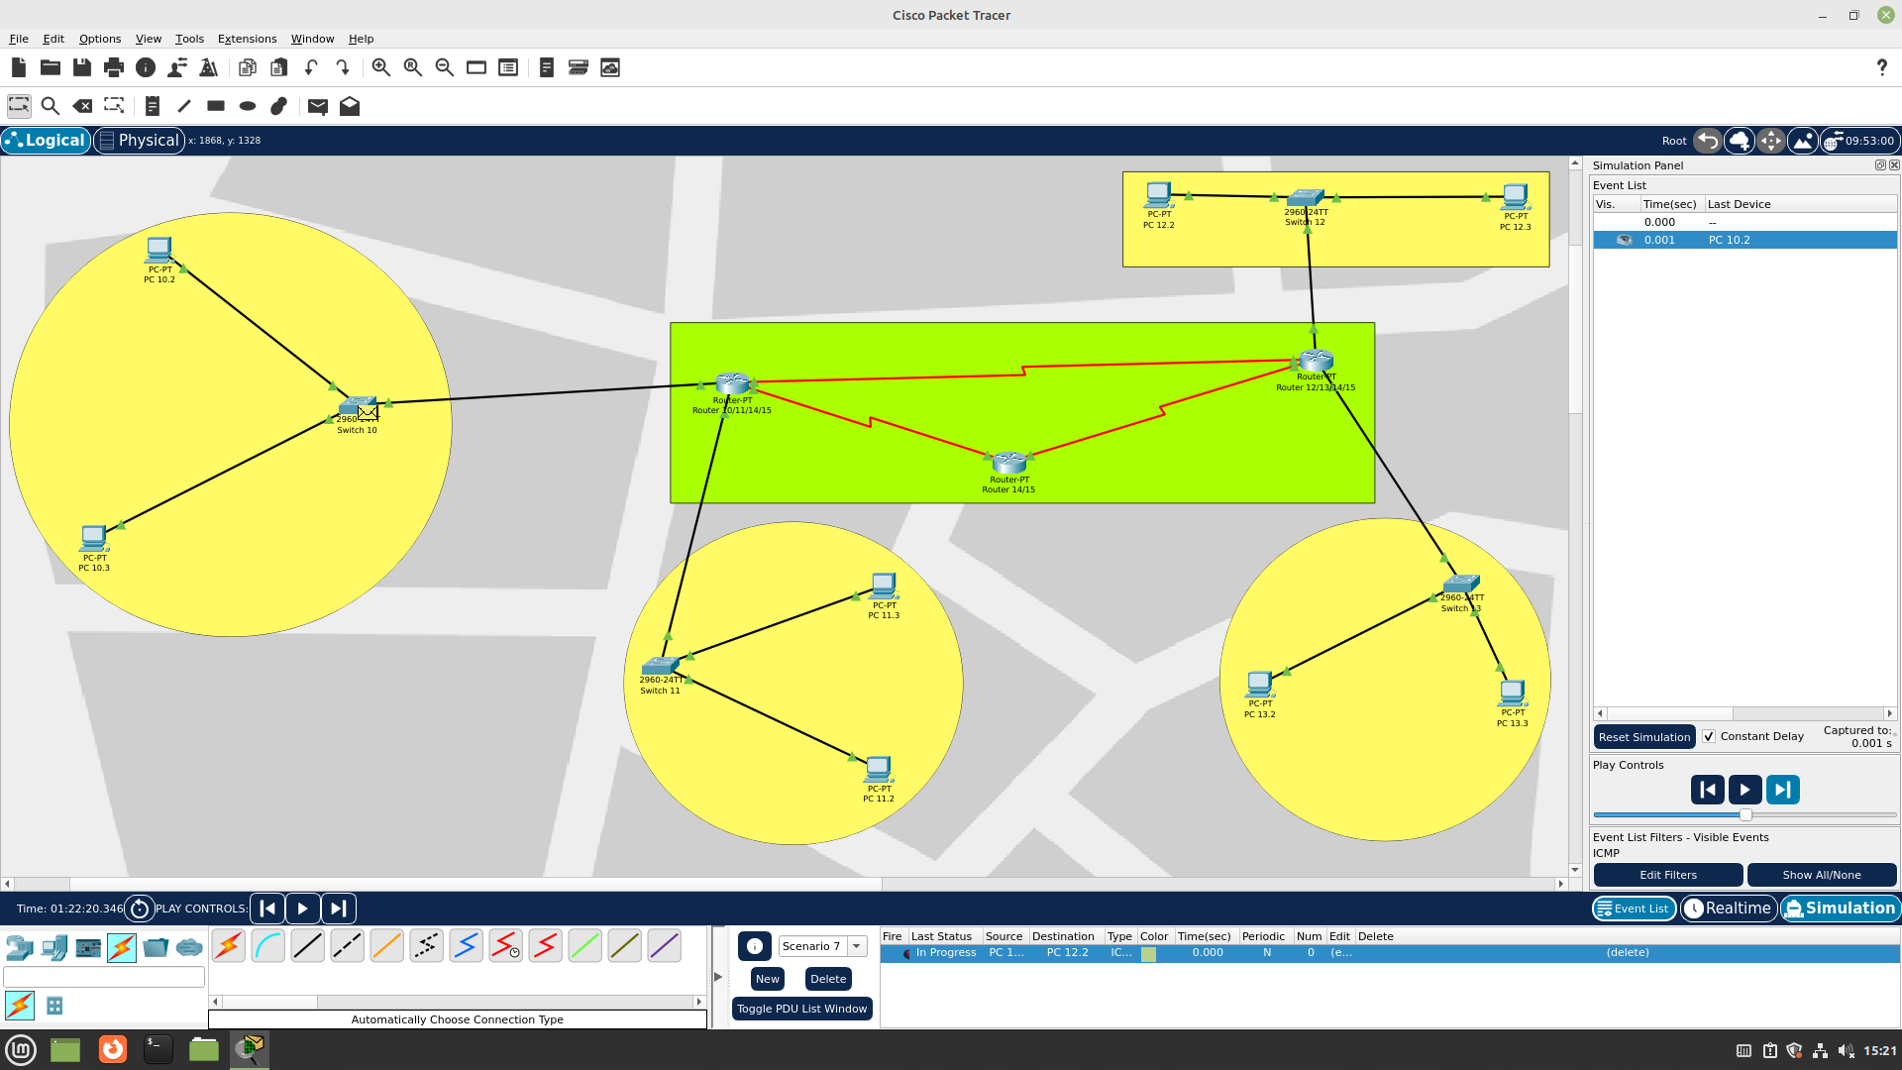

Step 3

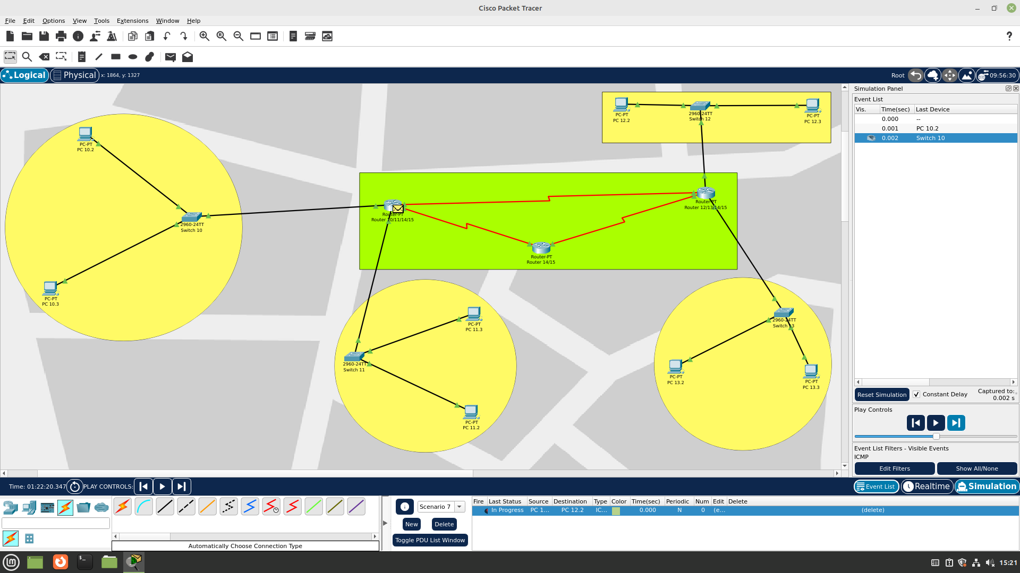

Step 4

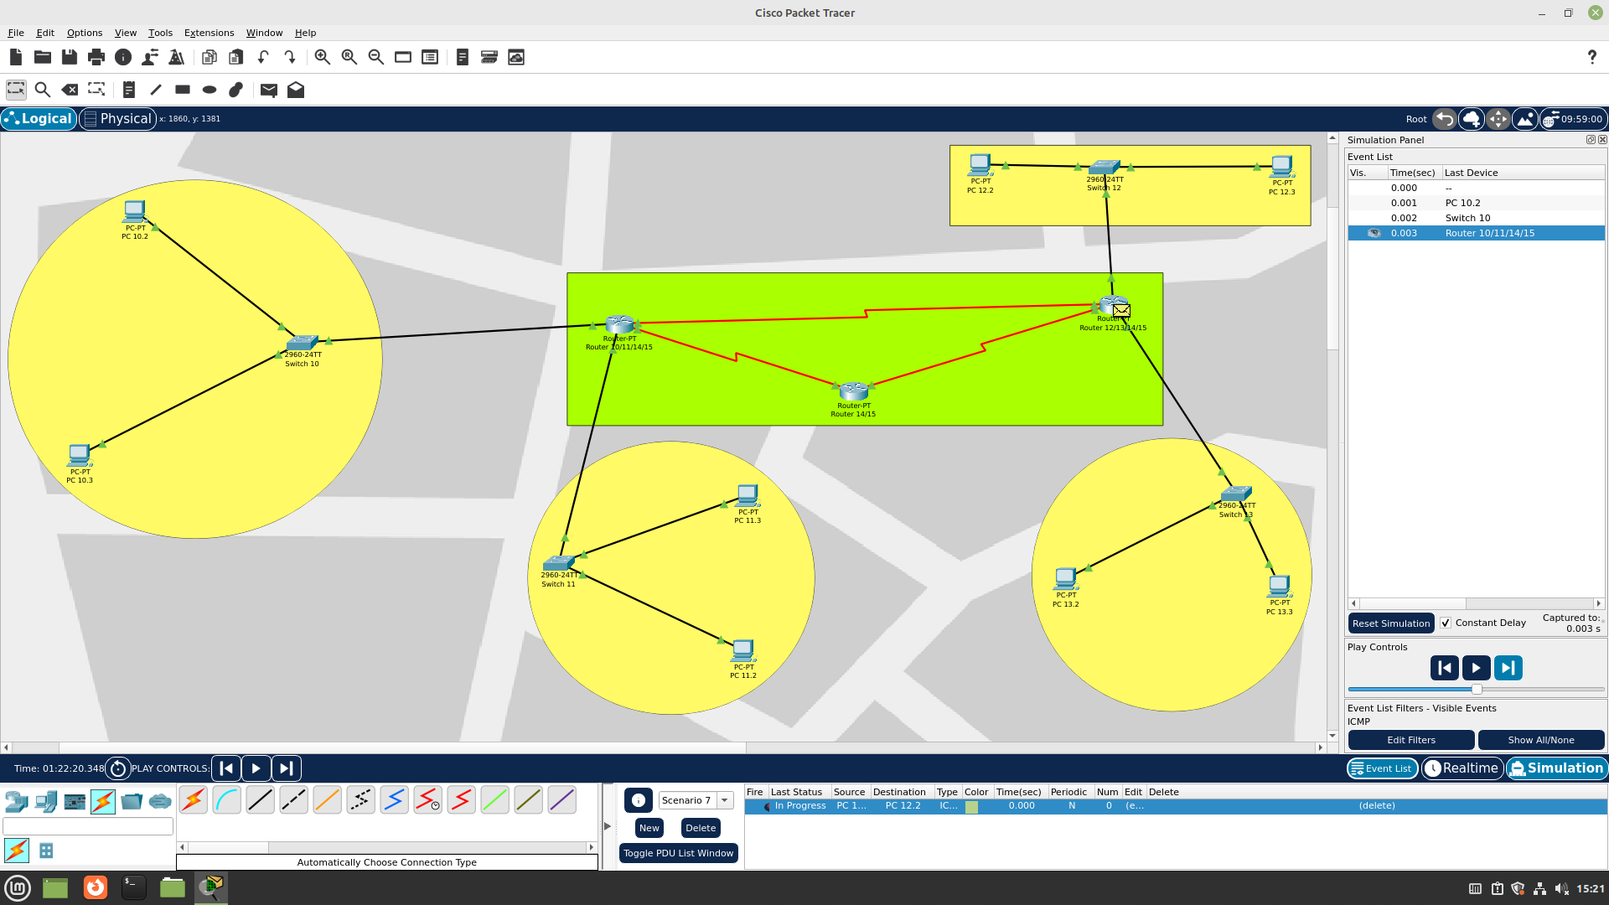

Step 5

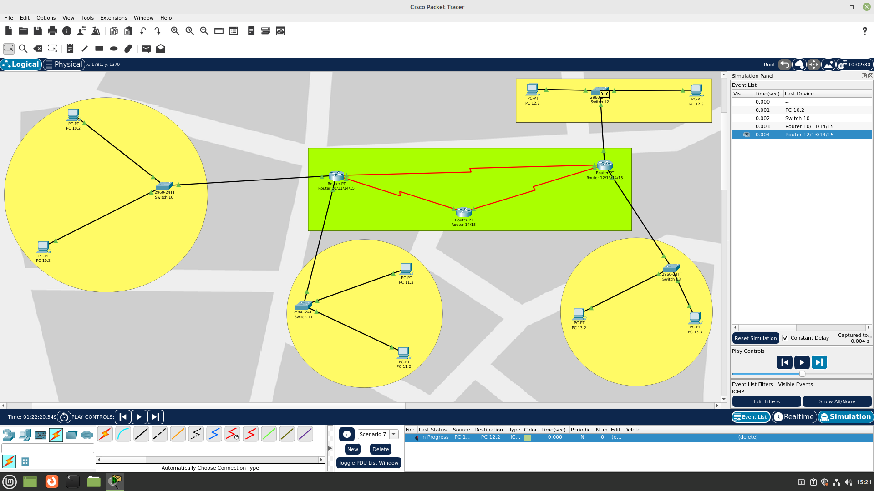

Step 6

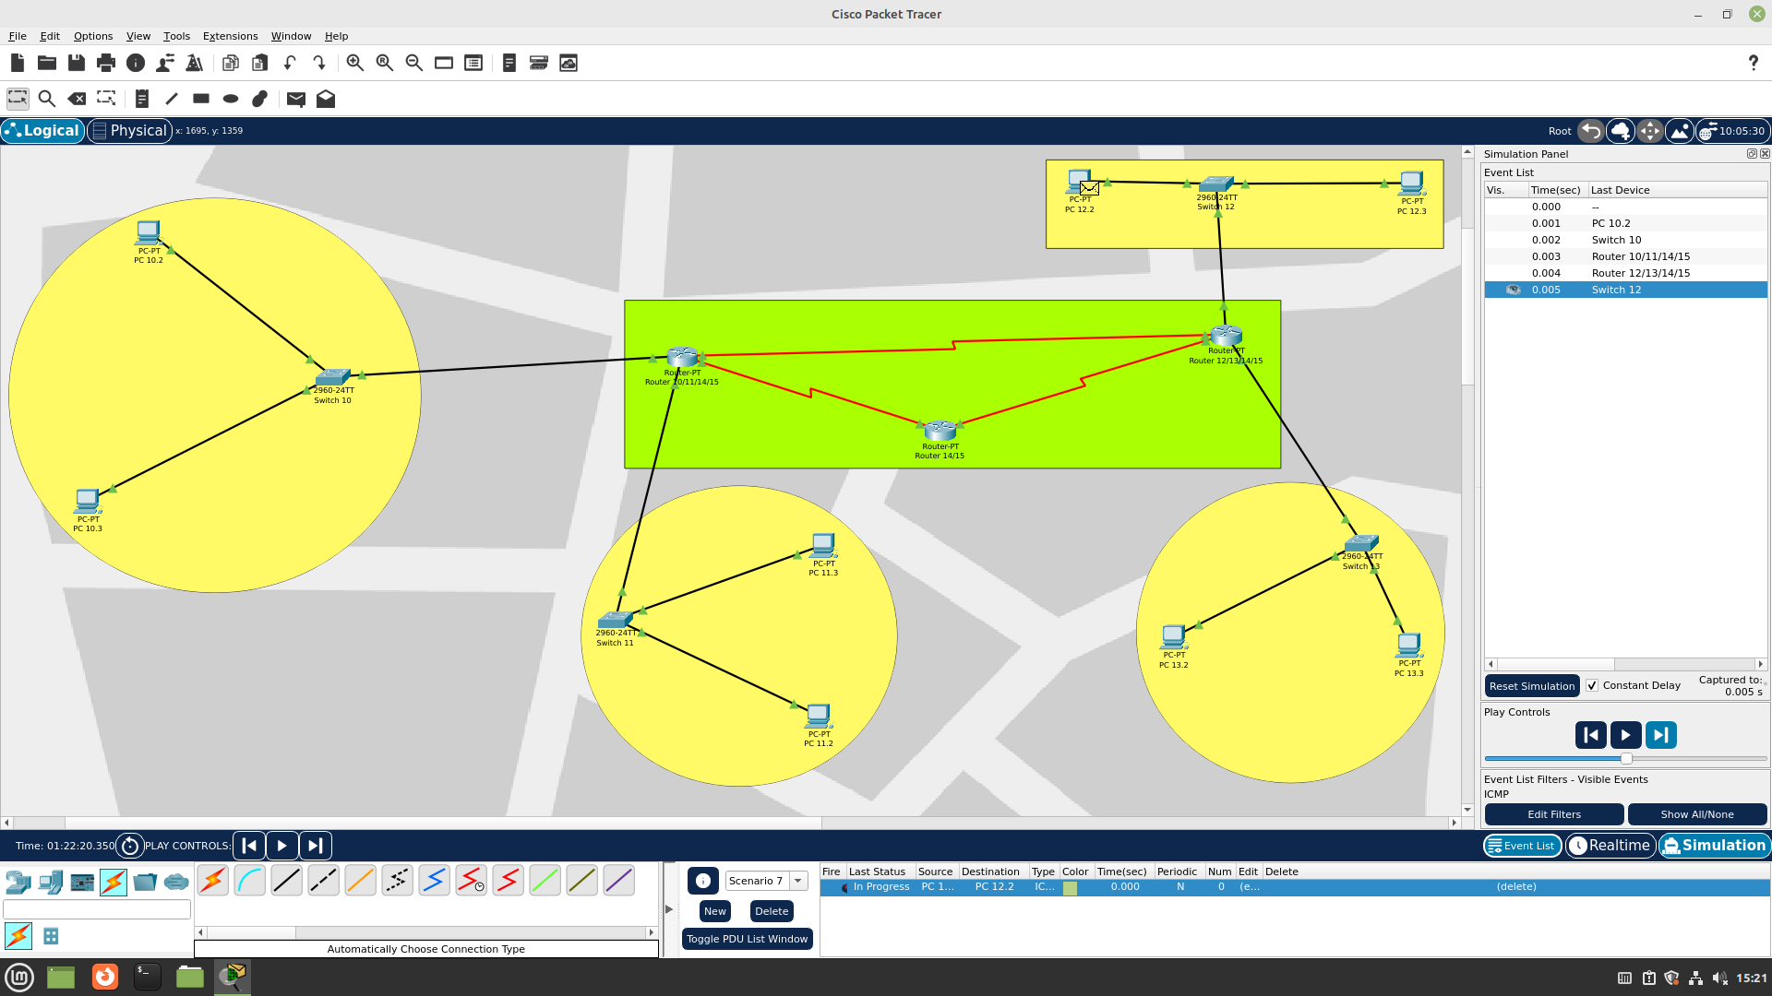

Step 7

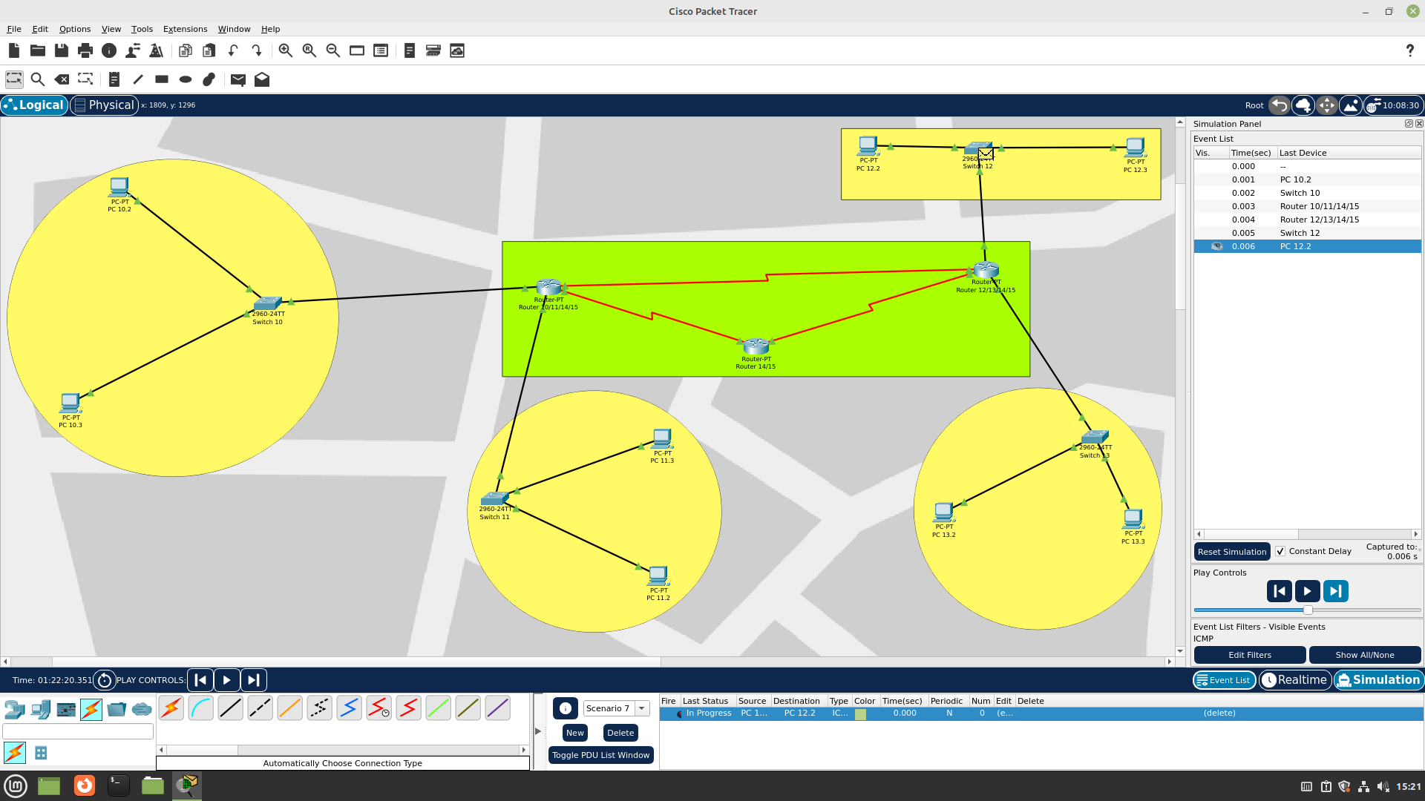

Step 8

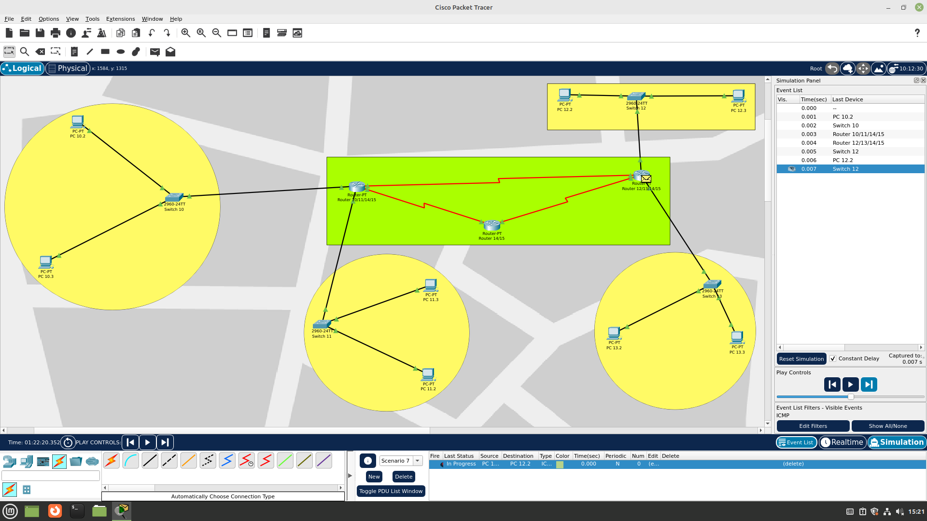

Step 9

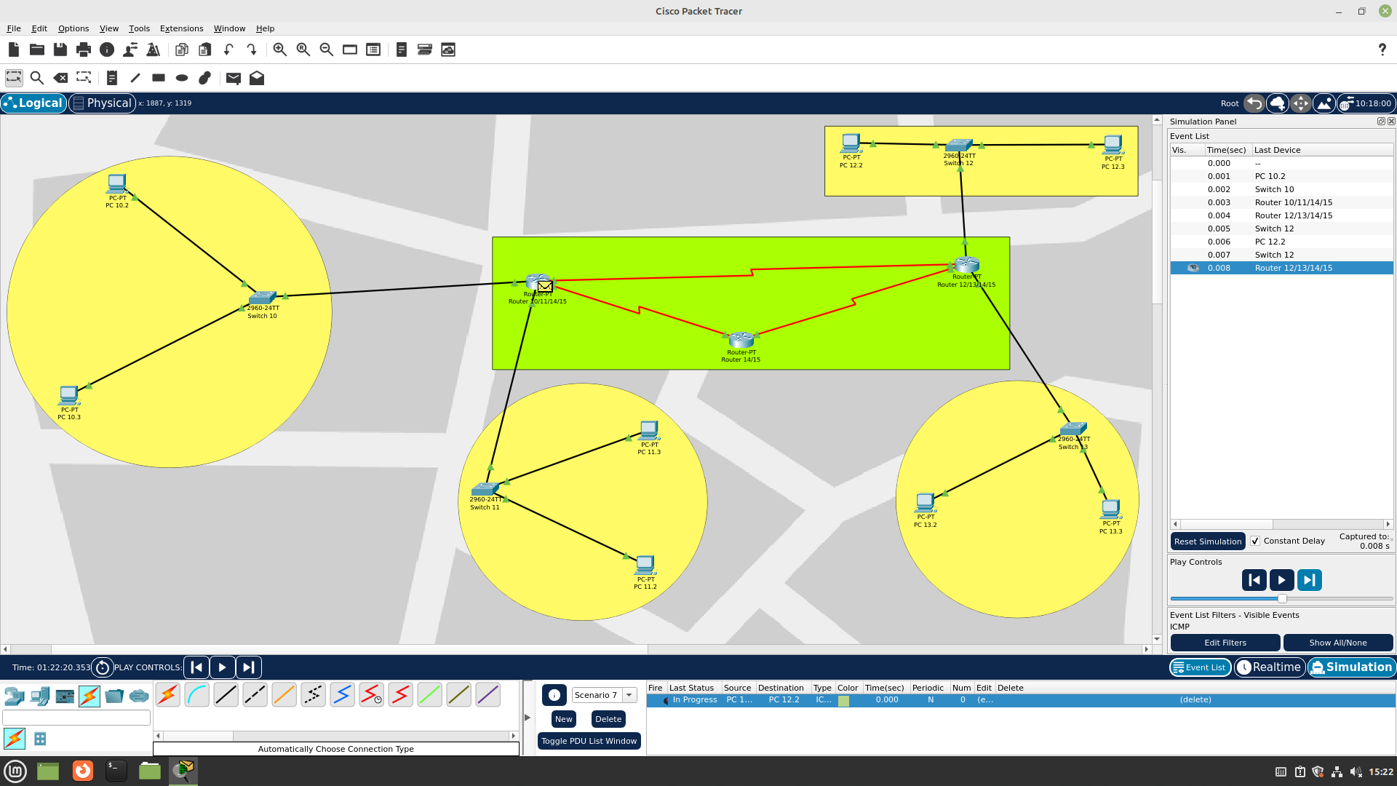

Step 10

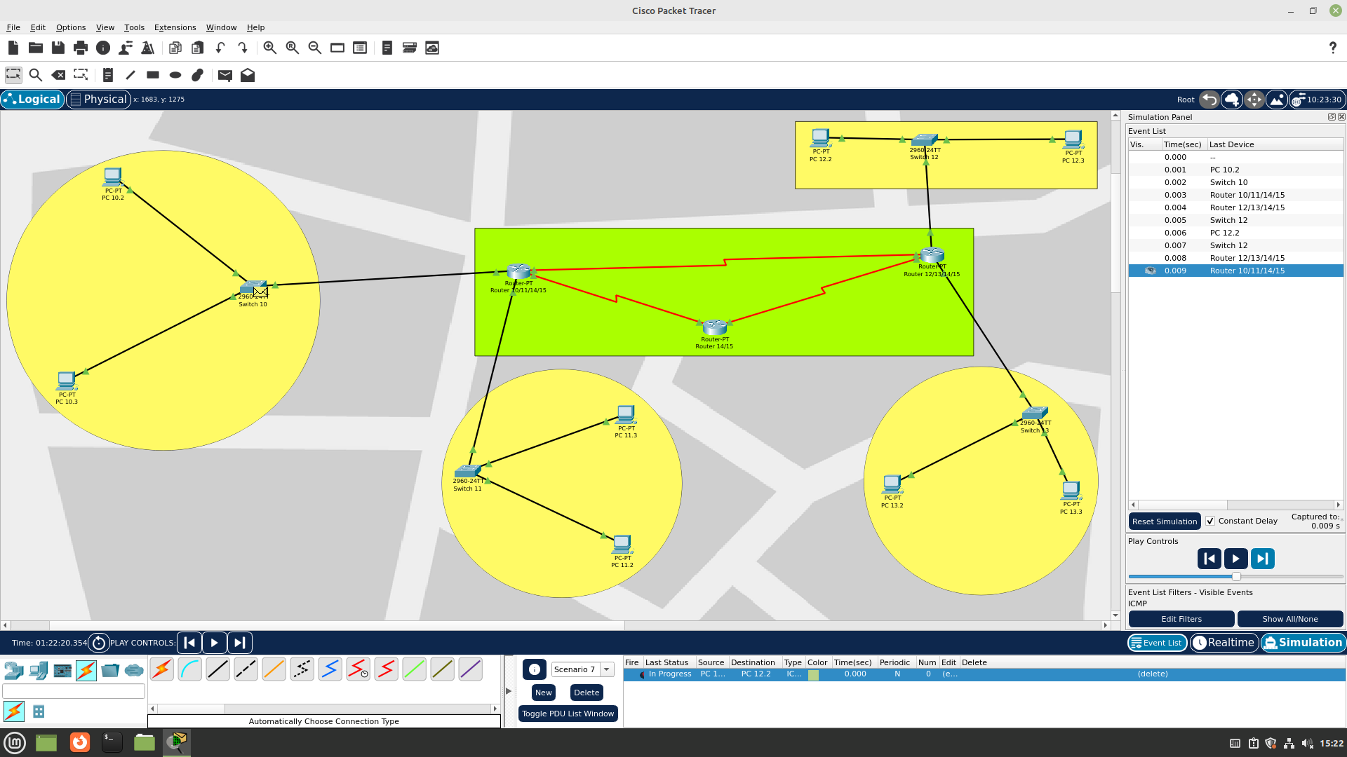

Step 11 – Successful Transfer

